**A1-1: Wireframing basics**

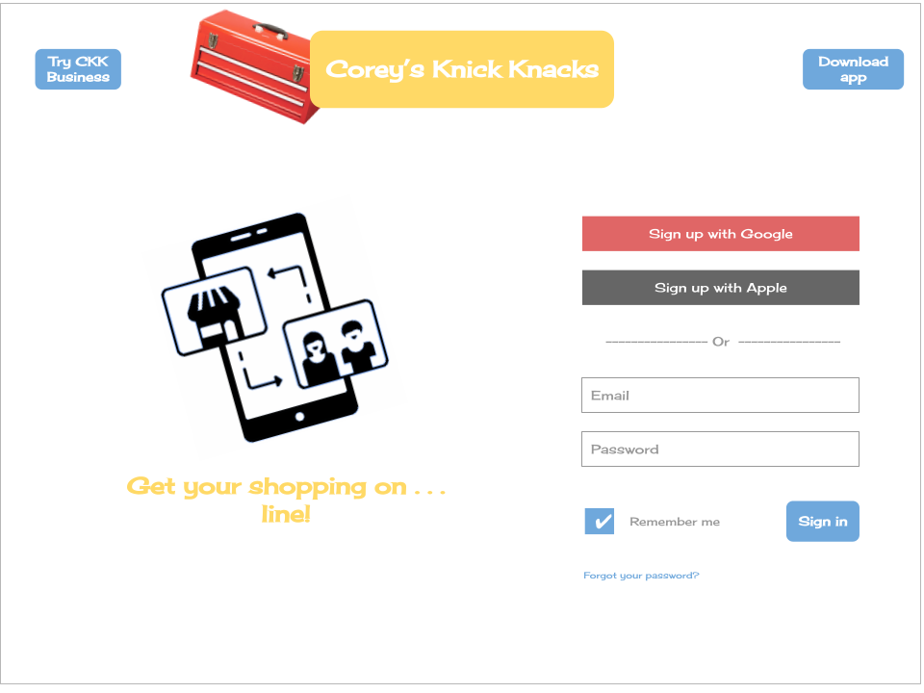

**Creative Common art used:**

**Toolbox -** [**https://www.pinterest.com/pin/675610381577614751/**](https://www.pinterest.com/pin/675610381577614751/)

**Online shopping icon -** [**https://iconscout.com/icon/online-store-1495399**](https://iconscout.com/icon/online-store-1495399)